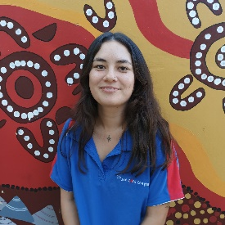
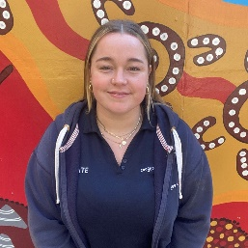
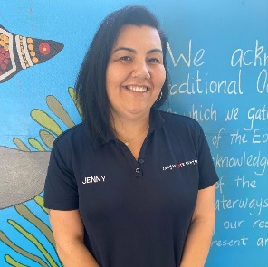

Kate Wilson Jenny Collins Irene Pusaviro-McMahon
Assistant Director Director/Nominated Supervisor Educational Leader

Quality education and care shapes every child’s future and lays the foundation for lifelong development and learning.
The early years of our children are critical for establishing self‐esteem, resilience, healthy growth and capacity to learn.
As we head into the 38th year of Coogee Care Centre I have reflected on where the service was and where it stands now.
Over the years Coogee Care has gone from strength to strength, it has stayed strong as a not-for-profit service run by families for families. In our industry holding this title is not an easy feat, many services like ours have lost their Centers to private companies, instead we have continued to hold on, fight for our amazing service and now offer not only in our eyes a high-quality service but in the department of educations eyes an EXCEEDING service.
Coogee Care Centre’s team and Committee have worked tirelessly to ensure our service faces any issues that have arisen, front on. In 2023 we saw a decline in our attendance rates which in effect saw a decline in our income. The ripple effect of this meant less children attending, less shifts for staff and a tighter budget. As a management team we needed to come together and work on ways and think outside the box on how to rebuild our attendance while still offering the same amazing program. As we head into a new year, unfortunately we are still in the same situation but collaborating and actively reflecting on how to move forward with less children will continue to be a priority for us to ensure the Centre is financially viable moving forward. In comparison to many other OOSH services we are still not seen as a “small” service and Coogee Care will adapt as needed, just as it has in the past.

This report is to showcase the amazing achievements CCC has made in 2023 and all the goals we have set for 2024. As you may or may not be aware, as an accredited childcare service we are guided by many regulations, compliance and frame works.
The national quality framework is what guides us and as a service are assessed on how we meet our 7 quality areas and all its standards in the framework.
This workload is not small and takes a tribe. Below you will hear from each team member who overlooks a quality area and what they led and achieved in 2023 and their ongoing goals for 2024.

Quality Area 1: Educational Program and Practice
Irene Pusaviro-McMahon
Educational Leader
The aim of Quality Area 1 of the National Quality Standard is to ensure that the educational program and practice is stimulating and engaging and enhances children’s learning and development. In school age care services, the program nurtures the development of life skills and complements children’s experiences, opportunities, and relationships at school, at home and in the community.
Over the last year, QA1 has implemented new practices for the programming team and staff to build knowledge on intentional curriculum decision-making, responsive teaching, peer scaffolding, child directed learning, planning cycles and critical reflection. This is ongoing for 2024.
QA1 2024 goals:
In 2024, our goal is to enhance engagement with families through our social media and communication channels. We've kickstarted this initiative by promoting our Instagram page in the school newsletter and communication emails. This initial effort has already attracted a few new followers, and we're committed to further expanding our reach throughout the year. To sustain this engagement, we've established a posting schedule, ensuring a minimum of two posts per week.
Some additional strategies we’ve developed to further boost engagement:
- Consistent Branding
- Responding to Comments and Messages
- Collaborations and Partnerships
- Promote Events and Activities
- Content Variety
Some strategies we hope to introduce in 2024:
- Interactive Posts
- Build our following.
- Support management.
- Community events and networking
- Refine budget

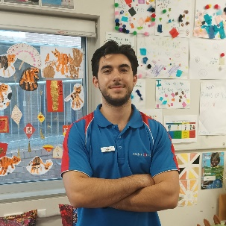
Quality Area 2: Childrens Health and Safety
Andre Domingues
RP/Area Leader
Over the past year the focus has been on improving procedures already in place to safeguard and promote children’s health and safety more effectively. The following reflect some achievements from the past year:
- Successfully implemented digital incident and toileting records on Xplor, in collaboration with Eva in QA6.
- Completed necessary risk assessments regarding sleep & relaxation, active playground, and psychosocial hazards in accordance with new legislation.
- Created a digital record of emergency equipment maintenance and testing.
- Developed a safer and more efficient method to store, provide, and document children’s medication.
- Compiled and simplified court orders.
- Digitised SDS forms.
This is in addition to the continuous work of maintaining, updating, and recording health needs and medication in liaison with parents, food supervisors, and management.
In 2024, QA4 aims to (The following is a non-exhaustive list that highlights some goals)
- Continue improving our practices in relation to Children’s Health and Safety, ensuring they are sustainable while also identifying areas in need of improvement.
- Record patterns and trends across digital injury forms to inform strategies to minimise risk and injury in the future.
- Liaise with the food supervisor to ensure our menu is consistently meeting the Australian Dietary Guidelines for children.
- Continue to practice and update emergency procedures.
- Collaborate with other QA leaders to always manage and support children’s health and medical needs in line with established best practice.
- Ensure staff are supported to confidently contribute to the health and safety of all children in our service.
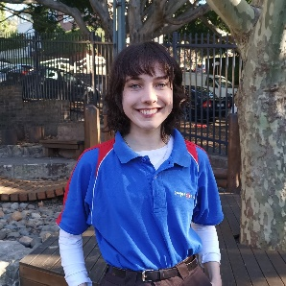
Quality Area 3: Physical Environment
Emilee Robinson
RP/Area Leader
Over the past year, QA3 has introduced new policies surrounding the outcomes of sustainability and reconciliation, as well as renovating procedures that have been previously implemented by former QA3 Leaders.
These include:
- The implementation of a new ‘Environmental Ordering Strategy’ to ensure the Programming team is ordering as sustainably as possible. This template also provides reflection on safe storage spaces for the prospective resource(s), how the prospective resource(s) will reflect the needs of multiple children, and safe maintenance and cleaning methods for the prospective resource(s).
- Collaborating with Randwick City Councils ‘Compost Revolution Program’, introducing a subsidised worm farm and compost bin for the services’ organic waste. The worm farm allowed each child to adopt a worm to take care of.
- Organising incursions run by the Reverse Garbage co-op to provide a hands-on educational experience for children on how to repurpose ‘waste’ goods.
- Streamlining long-term, before school care and after school care cleaning checklists and safety checklists that are completed daily and signed off weekly. These cleaning checklists have been specified to include the most sustainable methods to sanitise all equipment and toys within the service.
- Creating cohort and age-specific QA3 folders that include sustainable and cultural activities. These activities work closely with our RAP principles and are implemented by each cohort's programming team at least once a week.
- Liaising with staff to tag-out broken equipment and update the hazard register and needed. These hazards are worked-on in collaboration with the school and groundskeeper, whilst broken/unsafe equipment is taken out of floor-rotation to be disposed of. This year's primary hazard was the renovation of the COLA sandpit.
- Conducting termly ‘resource reviews’ with each cohort to minimise waste and use remaining resources mindfully.
In 2024, QA3 aims to:
- Create Safe Operating Procedures (SOPs) and formal processes for all hazardous tasks conducted within the service.
- Implement an educator-run ‘Gardening Club’ that works in conjunction with a 4-week Indigenous incursion run by Muru Mittigar.
- Liaise with Jenny and the school regarding the permanent use of the outdoor learning space for long-term and loose-parts projects for Coogee Care Centre that do not need to be packed away daily.
- Collaborate with QA5 to create an inclusive ‘calm corner’ in the centre that exists separately to the sick-bay.
- Collaborate with QA6 to implement meaningful interactions with the local community to reflect the unique geographical, cultural and community context of the service.

Quality Area 4: Staffing Arrangements
Kate Wilson
Assistant Director

Over the last year, QA4 has placed focus on maintaining quality staff, cutting staffing costs, increasing opportunities for staff professional growth and development, and enhancing the professionalism and conduct of our team. The following reflect some actions from the past year:
- Ensuring Staff Ratios whilst tightening staffing costs: Maintaining optimal staff-to-child ratios as outlined in the National Quality Framework, while cutting staffing costs where possible. This has included cutting one gate staff to only operate from Byron St, reducing staff’s non face to face hours, staggering shift end times, slightly understaffing to account for unnotified absences and including roles (i.e breakfast and gate person) in the ratio in BSC when we have a higher rate of children not attending their bookings.
- Promoting Ethical and Professional Conduct: Heightening the standard of ethical and professional conduct among staff members by implementing new staff procedures i.e leave, conduct and disciplinary action and holding staff accountable to these procedures. Emphasising the importance of integrity, respect, and confidentiality in all interactions. Providing ongoing guidance and support to address misconduct or ethical dilemmas.
- Enhancing Staff Qualifications: Rethinking how we offer and implement professional development, so that all staff members meet or exceed the qualification requirements of the ACECQA National Quality Framework. Rather than sending individual staff to professional development courses, implementing termly group professional development opportunities and support for the entire team.
- Strengthening Collaboration and Communication: Enhancing communication channels between staff members i.e new groups and chats on workplace to facilitate collaboration and consistent information sharing. Promoting a team-based approach to decision-making and problem-solving by continually asking for reflection and feedback on new things we implement, discussing decisions in team meetings etc.

In 2024, QA4 aims to:
- Foster Continuous Learning: Establish a culture of continuous learning and improvement among staff members by continuing regular group training, mentoring, and providing ongoing opportunities for professional growth.
- Prioritize Health and Well-being: Implement policies and practices to support the physical and mental health and well-being of staff members. For example, adopting an Employee Assistance Program, promoting work-life balance, and fostering a continually supportive work environment.
- Encourage and Empower Leadership Development: Identify and encourage emerging leaders within the service by providing opportunities for leadership development and advancement. Investing in succession planning to ensure continuity and stability in staffing arrangements.
- Promoting Diversity and Inclusion: Developing strategies to recruit and retain a diverse workforce that reflects the cultural backgrounds and experiences of the children and families served.
- Evaluating and Adjusting Strategies: Continuously monitor and evaluate the effectiveness of staffing arrangements in achieving desired outcomes related to quality of care, staff satisfaction, and organisational performance. Use feedback from staff, families to inform adjustments and improvements to strategies as needed.

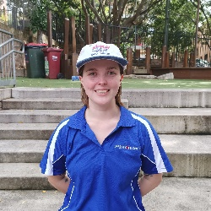
Quality Area 5: Relationships with Children
India Wyvill
RP/Area Leader

In the past year, one focus of QA5 has been continuing to develop and polish the previously implemented procedures of past QA5 managers and new introductions I made last year including, the behaviour of concern documents, and continually supporting educators when completing their obligations to QA5.
2023 has seen changes to QA5 including.
- Collaboration with Inclusion Development Fund Manager (KU IDFM) and working to acquire an Inclusion Support Program, specifically applying for funding for an additional educator to more closely supervise the children that require additional support during their time in our care. This procedure, includes assessing the inclusion barriers we are currently facing, reviewing our resources and capabilities, justifying the need and positive outcomes of receiving this funding for an additional educator and collaborating with the parents of the child receiving the support. This process took time but was ultimately approved during 2023 vacation care and will continue throughout term 1. This meant the development of an “inclusion team” which is made up of people with the skills and enthusiasm to work closely with a child that requires it. I am in constant communication with this team to ensure they are supported during their time on inclusion. We will assess this program after Vacation care to evaluate its success.

- The ongoing development of the Reconciliation Action Plan through Reconciliation Australia. The use of these ‘plans’ in school and care environments have enabled organisations to sustainable and strategically take meaningful action to advance reconciliation. We follow the structured approach from Reconciliation Australia and their framework of respect, which has and will allow us to make significant strides in our inclusiveness and support for Aboriginal and Torres Strait Islander people. This in turn teaches the children in our care respect and creates an even more inclusive environment for our Aboriginal and Torres Strait Islander identifying children.

- 2023 saw a focus on policy reviews and proposals. One review was made regarding unacceptable behaviour and incidents. The review came about after identifying the current ineffectiveness in its efforts to protect both children and staff at Coogee Care Centre. In collaboration with the QA6 leader, we created proposed amendments to the policies that we believe would enshrine the beliefs of the centre when it comes to intolerance of violent behaviour against both children and educators. One proposal made was the inclusion of an Employee Assistance Program into Coogee Care Centre. While this proposal seems out of the QA5 standards, I believe that the unique psychosocial hazards associated with this line of work that affect the educators, when addressed through the scheme, will ensure that educators are as supported as possible which will then ensure their utmost ability to care for the children. This proposal also came about after the development of the Inclusion Support team. Working with a child that requires additional support can require an educator to feel the more heightened psychosocial hazards, as well as the physical hazards. This proposal was seen as an extension of the QA5 standards to support the children through supporting the educators.

As we enter the final weeks of Term 1 2024, we have outlined the aims of QA5 in 2024.

In 2024 QA5 will aim to:

- The annual review of the Strategic Inclusion Plan (SIP), which is a self-guided assessment and planning tool for care services assessing our Inclusion Support Plan (ISP). The SIP is annually developed to recognise a service’s current inclusive capacity and outlines our objectives for inclusion practices.

- Continue and build the Reconciliation Action Plan (RAP). The Rap will always be a annually continued project, the RAP is never completed as it is a fluid program and will continue to build a services inclusive and reconciliation practices.

- 2024 will see a focus of collaboration with the QA3 leader as we develop upon our centre space to create an opportunity for the children to regulate. Standard 5.2 element 2.22 details the necessity for “self regulation” and the importance of a service to provide a space for it. In collaboration with QA3 we will create this space permanently in 2024.

- Work towards the implementation of the proposals and policy reviews. Due to the importance of proposals, 2024 will see a focus on making those necessary changes.

- We will continue collaboration with IDFM and Innovative solutions to address our funding requirements in our attempts to create an entirely inclusion environment.

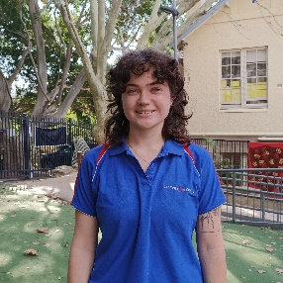
Quality Area 6: Collaborative Partnerships with families and communities
Eva Klok
RP/Area Leader
The aim of Quality Area 6 under the National Quality Standard is to recognise that collaborative relationships with families are fundamental to achieving quality outcomes for children and that community partnerships that are based on active communication, consultation and collaboration are also essential.

This past year the focus was establishing consistent communication standards between us and the families. This meant working on a brand kit to keep our aesthetic consistent throughout all our communications. This has led to a more consistent posing on social media and on our website, which in turn has led to better engagement.
We have also worked on becoming specific for what channels are used for what type of communication. This has been achieved by channelling most of our information through the Xplor app. We now use the Xplor app for everyday updates and our incident forms in addition to signing in and out and making bookings. A project we also had to take on was identifying which parents were not using the app and troubleshooting their issues individually to get everyone on the same page. We have now gotten most parents not using the app to get on board.

Other achievements have been:

Orientation - Updated the kindergarten orientation process, including before and after school care videos to explain the routine for the kindergarteners, a helpful info page with information for new families, and a presentation at the school’s orientation day.

Reconciliation Action Plan - For the RAP, we created a hashtag and weekly post series called Warami Wednesday, which showcases our programs engagement with Aboriginal and Torres Strait Island culture on Instagram.

Local Excursions during Aftercare - As part of the Senior Program, we organised community excursions down to the beach, and to a local day care centre.

Fundraisers - We hosted fundraising events like Pink Ribbon Day and Australia’s Largest Morning Tea.

In 2024 QA 6 will aim to:

Market/Festival Days - Hosting stalls at local festivals (eg. spot festival) where we can engage the wider community and promote our services.

Community Incursions: Getting local police or firefighters or paramedics in to host talks with the children. We will also continue our existing incursions like reverse garbage, Little Warriors and Coogee White Tigers.

Child - Led Projects - Have children more directly involved in long form projects, like fundraising. Currently the dance club are working on performances for our next community event. We aim to have at least one long term project running in every cohort throughout the year.

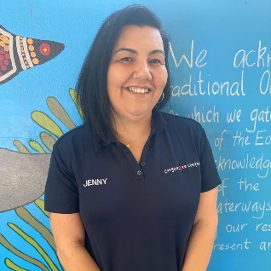
Quality Area 7: Governance and Leadership
Jenny Collins
Director/Nominated Supervisor

The aim of Quality Area 7 under the National Quality Standard is to support effective leadership and management of the service that contributes to quality environments for children’s learning and development. Well-documented policies and procedures, well-maintained records, shared values, clear direction, and reflective practices enable the service to function as a learning community.
An ongoing cycle of planning and review, including engagement with families, creates a setting for continuous improvement.
In 2023 We-
- Tech updates: A project plan was put in place to upgrade our hardware and implement ongoing software support. We now have four upgraded workstations that are set up for flexible work. Onboarded infoxchange as a remote software support company. All Calanders between Admin, Ed Leader, Assistant Director and Director now sync.
- Reviewed transitions (introduced Cohorts) and re structured staffing. This has given opportunity for the team to develop skills and in the absence of staff in any given position we now have trained team members to cover.
- Staff performance reviews: All 2023 staff completed their performance reviews and set professional goals for 2024.
- HR: With the support from Employsure, all staff contract and confidentiality agreements were updated and now in line with the fair work act. Employee handbook was updated and rolled out to the team.
- WHS: Organised a site visit with the WHS team from employsure to come and complete a compliance assessment.
- Budget and Finance: Worked with both Matt.S and Viridity to continue to reflect on finance and budget.
- Marketing: Promotional video and YouTube channel. Instagram and comms have also been refreshed and this in affect has made us more visible to our community.
- Compliance: Kept up to date with all new compliance/regulations from department. We have two staff who have completed the Food Supervisor (accredited) Course and all team members have completed a food handling PD. We introduced our commitment to Childrens safety and promoted it through our community.
In 2024 QA7 will aim to:
- Organise Training for Approved Providers (CCC Committee) to help understand roles and responsibilities.
- Continue to collaborate with School P&C
- Continue to reflect on procedures and systems to manage risk and enable effective decision making and operation of the centre.
- Effective Self-assessment tool: Manage and oversee all quality area leaders continue to update their self-assessment tool with any updates, reflections, and goals.
- Update our service philosophy: In collaboration with staff and community. Ensure our philosophy promotes the values of the service, team, children, and community.
- Ensure software is protected: Work alongside infoxchange to build sharepoint for our service. Transition from Dropbox and google drive to Sharepoint.
- Finance: Work in budget with new attendance rates and work to ensure the service continues to be financially viable.
- Policy and procedure Reviews: Stay compliant with all policies.

Thank you!
There is never a dull moment in the world of OOSH and one day is never the same as the next.
For this reason, Coogee Care Centre would not operate without all our amazing stakeholders and team.
Coogee Public School:
Matt and Cari, it goes without saying how much I appreciate our working relationship. Whenever I am networking within the CCC industry I am always so proud to openly flaunt how amazing we work with our school, the staff, and its leadership. We will continually come to an understanding and agreement, and I believe this is because we all hold the same values and care for the children in our community.
The Coogee Care Team:
There is no such thing as Coogee Care without its team. Each of the staff brings value, culture, and experience. The bonds and trust between the children and Educators are one that is priceless.
In the last 12 months we have had so many educators stand up and ask to take on more responsibility, whether it was to take on a permanent role or become a cohort coordinator. This has shown both passion and drive. Janine, as a food supervisor you have worked hard to work in budget and still spoil the children with so much variety. Kara thank you for the work at the front desk and keeping our parents in line (even when it isn’t easy).
Responsible Persons and Area Leaders.
I have said it many times before and I will say it again. Without the trust in you I do not get to leave the service. Each one of you should be proud of your 2023 achievements. Although you have come across challenges along the way, the want to step up and be a leader is commendable. So, thank you.
Kate and Irene:
As usual I get to these two and I don’t know where to start. A day in the life of Coogee Care can bring many ups and downs. Together we have smashed goals and continue to set ourselves more. We laugh, we cry, we hold each other accountable and most importantly we work hard to hold each other up!! Thank you for another year of craziness and I would not go into the new year with anyone else!
CCC Committee: As full-time working parents, taking on a volunteer role is not for the faint hearted. Without you all it would not be possible for CCC to offer its service as a not-for-profit community service. Your time and support are priceless so thank you.
Santhan, Rosie and Matt. Thank you for your endless support. The background work that is put into this service does not go unnoticed and I thank you for that. It has been a year of learning and I look forward to another year of growth and kicking goals with you all.
